# Paragraph Card

## Description

This feature includes a pill-shaped content container with the ability to include a link. It offers designated fields for a paragraph title and body, along with an option to include a date. Additionally, there are positioning options for the card: right-aligned, left-aligned, right bleed, and left bleed.

* Card Placement Right

* Card Placement Left

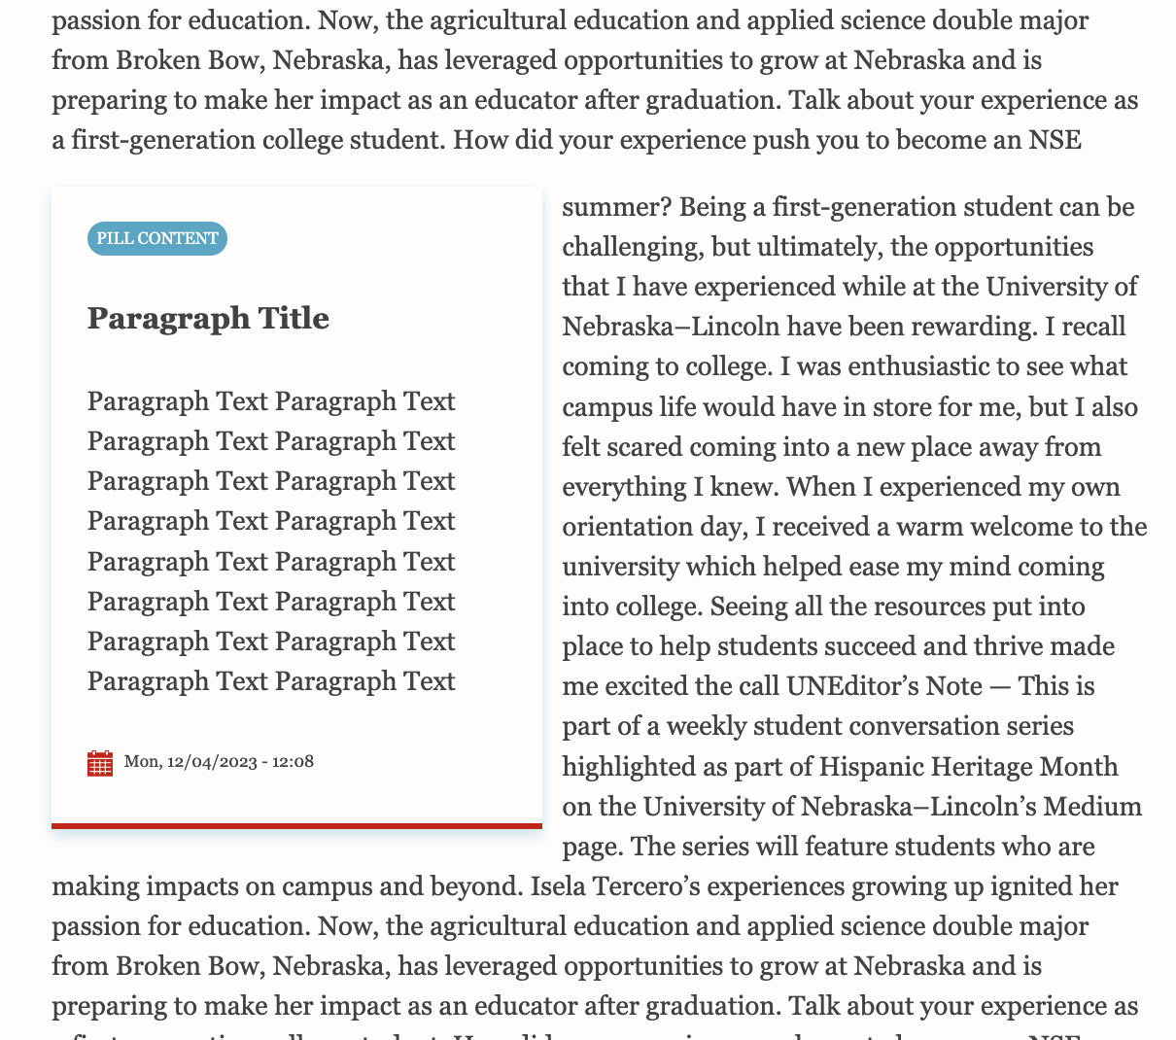

* Card Placement Right Bleed

* Card Placement Left Bleed

